
A Guide to Living in a Shared House
How to live harmoniously and comfortably
Learn how to

- Be a great housemate
- Operate a dish cloth
- Not upset anyone
- Operate domestic equipment
- Be reasonable
- Change a light bulb
- Make sure you get your deposit back
- And much much more!!




Most problems in shared properties seem to arise from tenants not taking personal responsibility for communal areas – The ‘someone else will do it’ attitude. People all living together can generate some disagreements. In this case we would advise calling an informal meeting of ALL house-mates to ensure a smooth running household. Most problems can be sorted out by talking.
Our 4 main criteria for living together; Don’t be noisy, Keep the place clean and tidy, Pay the rent on time and Have a mutual respect for others. Simple!

Overnight Guests
It is a common courtesy to inform other housemates if you have the occasional overnight guest. How would you feel bumping into a stranger in the middle of the night? It’s generally accepted that no more than 3/4 nights a month is acceptable for overnight guests. Any more than this and you are breaching your tenancy agreement and run the risk of being evicted. It is also extremely unfair on your housemates and can lead to bad feeling. Please inform NSP Resources if you think sneaky housemates are abusing this rule.


Viewings, Inspections & Maintenance
Viewings and maintenance will need to be carried out at the property from time to time. Whole house inspections are carried out at approximately 3 month intervals. All tenants will be informed in writing at least 24 hours in advance. Please report any maintenance issues immediately.

Your Contact Information

Please inform us immediately of any change of email address and mobile number. Failure to do so could result in an embarrassing situation should we have to do a room inspection . . . .


Fire The hall, landing and stairs must be kept completely clear of any obstruction, at all times – this is a requirement of the local authority as it forms the fire exit. Keep all your belongings in your room.
In the case of fire – raise the alarm, (Shout ‘Fire’ as loud you can!) call the fire brigade, 999, from a safe place, do not attempt to extinguish the fire and ensure doors are closed behind you.
This is a non smoking property, when smoking outside the property; please step away and close the door to prevent smoke entering the building.
Please do not place toasters under kitchen units when in use.
Do not use deep fat fryers at this property.
If you introduce any of your own furniture into the house, please ensure it complies with the safety fire regulations. All common sense stuff!
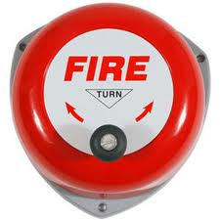
Fire alarm system
The fire alarm system is very sensitive and will be activated by the slightest whiff of smoke!

A false alarm in which either an engineer or the Fire Brigade are called out, will result in a substantial payment being made by whichever tenant has been naughty.
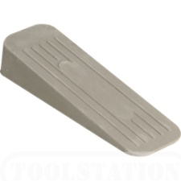
Kitchen Door
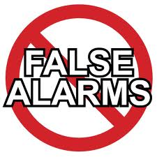
Be aware that if you decide to wedge open the kitchen door, smoke from cooking food in the kitchen may set off the smoke alarms, to the annoyance of anyone else asleep in the house!
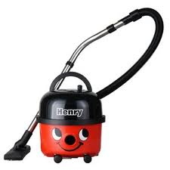
Cleaning
The communal areas are the responsibility of every tenant to keep clean. Tenants are expected maintain the property to a good standard of cleanliness and hygiene. It is advisable to draw up a cleaning rota with other housemates over a bottle of wine.

Security

It is very important to close all windows and external doors securely when leaving the property unattended. Please also lock the doors behind you when you go out in the evening even if other tenant are at home (if the other tenants are in their rooms they may not realise the door is unlocked before they go to bed). There have been some reports of theft from student houses in the area. You may be liable for missing items if it is determined that it was YOU that left the door unlocked!
Keys Please be careful with your keys - we charge for replacements. Guests, friends and family members should NEVER be given their own keys.

Blocked drains
Take care not to allow excess hair to clog the shower and basin. Also take care what is deposited into the kitchen sink and WC – You may have to pay for call outs and plumbers are b****y expensive!

Heating

In very cold weather please do not turn off the heating when the property is left empty. Set the timer so that it switches on for two bursts a day. This is to ensure that pipes do not freeze. Failure to do so may result in tenants being charged for any subsequent damage and repairs and plumbers are . . . . . (see above)

The overall heat of the house can be adjusted with the thermostat and timer. (see the red folder for instructions) Individual room temperatures can be adjusted with the thermostats on the radiator in your room. No need to adjust the boiler and take into account your carbon footprint on your home planet.
Monthly Bills

Gas and electric bills are currently not capped. However, if it is felt that tenants in a particular house are abusing this then the policy will be reviewed and the excess may billed to tenants proportionately. It is therefore in the interest of all tenants to keep bills to a minimum. Just be sensible – don’t leave the heating and lighting on all day – it will upset someone!
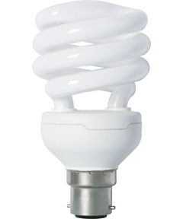
Lighting
You have a responsibility to replace blown light bulbs in communal areas immediately to ensure the safety of all tenants. There are different types of fixings – BC or ‘Bayonet Cap’ energy efficient type is shown.


Emergency Numbers
There is a sign in the hallway detailing all the emergency numbers you will need. These are the numbers you should call should the property require EMERGENCY repairs out of office hours. Please keep this safe.

Emergency Insurance 24/7 Helpline
Contact number 0844 8485261
For any suspected gas leak please contact Transco 0800 111 999
These numbers are ONLY to be used in the case of an emergency.
If the contractor deems the repair not to be an emergency, YOU will be charged for their call out fees and you don’t really want to do that, do you?
If you do have to make an emergency call out, please inform NSP Resources first thing the following morning either by
Email office@nspresources.co.uk or Tel 0844 414 2738


Waste collection
Please ensure you return the bin to its correct place ASAP after it has been emptied. Try to get all the rubbish in the bin with the lid closed. Let’s try not to make it easy for the rats!!
There is also the usual array of recycling containers for plastic, cardboard, food, foil, cans, glass. Please make sure you use the different coloured bins correctly or the council won’t collect. (ask your housemates if you aren’t sure)
Condensation & Damp

We occasionally have complaints about damp or mould. This is usually caused by condensation With 3 hot adults in the house showering every day, plus cooking and the sometimes necessity of drying clothes in the house, the moisture level in the air increases so much that it can’t all escape, causing damp and mould. Mould comes in many wonderful colours - Green, orange, black…
Here are a few points to avoid problem and treat this problem.
- Cooking - Cover pans when cooking and open a window and use the extractor fan. Make sure the fan is working correctly.
- Washing clothes – Put clothes out to dry whenever possible. ( Also makes them smell better) If you do air them in your room, leave a window ajar.
- Close kitchen and bathroom doors when these rooms are in use as these stops the moisture reaching bedrooms.
- Ventilate cupboards and wardrobes. Don’t put too many things in them as it stops air from circulating.
- Moisture is produced every day by our breath. When at home it is a good idea to ventilate a room by leaving a window slightly open.
- It is also good practise to open windows wide for a few minutes every day to ‘air’ the house and let the moist air out. Dry air in a house makes it feel warmer, so a better aired house uses heat more efficiently.
- When showering and bathing, ensure you ventilate the room afterwards by throwing open the window and using extractor fans where provided.
- In the morning, if condensation is spotted on the window, wipe it down with kitchen roll or a cloth. This will make you a better person!
- Don’t keep opened food in the fridge or cupboards past it’s sell by date. Either eat it or give to a housemate to eat.
- Do not dry clothes on the radiators in the house. This is usually the biggest cause of mould problems. We have supplied an indoor clothes dryer – use it!
If you start to see the first signs of black mould, it can be cleaned away easily using a bleach/water solution or specific mould spray. Dispose of cloth afterwards to avoid further contamination and please inform us.
- The first signs could appear around windows, in the silicone sealant around the bath, shower, and sinks. Mould may also form in the washing machine powder drawer.

- If food is left in the fridge then it will form here too and this can spread. The longer the mould is left the worse it will get.
As tenants you have a responsibility to keep the property in a good state of repair, and take steps to ensure it does not become a problem. Work together to ensure a nice safe environment. If there is a damp /mould problem when you leave the property you will be charged for the extra cleaning/remedial work involved.
Communal Areas
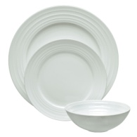
Please do not leave ANY of your personal belongings lying around in communal areas. Other tenants may be too polite to tell you it bothers them! There is plenty of storage in your room and in your personal kitchen cupboards.
If you think an unused item has been ‘hanging around’ the kitchen or bathroom, check with other housemates as to who actually owns it – if no one, dispose of it. Be power crazy and ruthless!


Generally
No pets are allowed at this property, not even rabbits. Grrrrr!

We find that a house runs smoother when those who live there have a little respect for each other, this could be as simple as

- Closing doors quietly. Shhhhhhhh
- Cleaning up communal areas after use, 24 hours max!
- Not playing music too loud (use earphones?)
- Not turning TV up too loud (see above)
- Sharing any jobs or working out a rota (House meeting & bottle of wine)

- Being considerate – it’s why God put you on this planet!
- Using your indoor voice whilst indoors

- No whining – housemates will roll their eyes behind your back!

Tips For Keeping the House Looking its Best

Here are some quick and simple cleaning tips to help keep the house and furniture looking its best, follow these to help save money and make sure you get your deposit returned. According to www.mydeposits.co.uk one of the main reasons that landlords stop money from a tenants deposit is to cover the cost of cleaning, not just your room but your % of the house. Respect.
- Tenants need to defrost freezer periodically.
- Oven: Place a layer of foil in the bottom of the oven to collect spills. Replace when dirty. Yea it’s a pain, but housemates will see you as their ‘Leader’.
- Grill pan: Place a layer of foil in the pan so it covers the top edges. This will catch all grease and fat. Replace after use . . . . Leader!
- Grills: Once every couple of months, soak these overnight in biological washing powder, they will come up as new! R-e-s-p-e-c-t

- Shower: You can use a shower de-scale spray on the shower screen and shower head and ventilate the room, to avoid mould. Cool!
- If you spill something then treat immediately to avoid staining. (Always remember this throughout your life)

- Coke is the probably the best cleaner on the market. (The drink) It cleans sanitary wear, sinks, taps, cookers and many other things. Minimal elbow grease needed. WC’s - just pour the coke into a toilet and leave it overnight and in the morning –‘ping’! Ha Ha - imagine what it is doing to your small intestine?! Drink water – it’s free!
- If you have failed to open a window and there is black mould on the walls there is no point in painting over the mould because it is a living organism and will quickly come back to haunt your dreams. The walls need to be cleaned, then neutralised with white wine vinegar to kill the mould and when it is dry a quick coat of emulsion will restore the wall to its former glory. You can do this and your landlord needs never know!!

- A dirty microwave is easily cleaned with a cup of lemon juice mixed with sodium bicarbonate placed inside and micro-waved for a couple of minutes. The lemon will evaporate and condense onto the metal surfaces melting the grease ready for a quick wipe out. The same mixture can be warmed and used to clean and deodorise a fridge or freezer. Tell your housemates to try it as a scientific experiment.

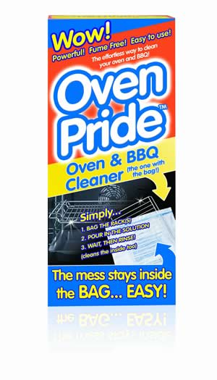
- If by some bizarre occurrence you create a dirty oven, there is a good product called ‘Oven Pride’. It comes with a bag into which you put your oven trays and pour some of the liquid. Leave over-night and in the morning the grease has melted leaving the trays shining like new. The product comes with full instructions – now all you need to do is pour the remaining liquid into the oven and spread it around, within a few hours the oven is clean and ready to wipe out – again, very little elbow grease needed. Ps wear the gloves – it burns!!

Living Together . . . . (Forced smile)
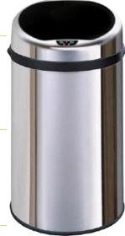
- Make sure you avoid arguments about the bin by making a rule about it. The first person who finds a full bin puts the bin bag out. Always check if you are running close to the end of the bin liner roll, otherwise its overflow time. Playing 'Bin Buckaroo' just isn't clever or hygienic.


- For some reason, the fridge is a particular bone of contention. If it drives you mad when other people take your milk then consider labelling it 'Milk experiment # 1’ or ‘Urine sample’ on your carton of milk. No one will touch it. In fact, you might free up a whole fridge shelf in this way...


- Make a rota. Some (lazy) people find these restrictive and may claim to be illiterate, but it's a fair system and if you work it out well beforehand, it can really pay off. It's up to you how you arrange it: you could make sure each person takes responsibility for one room or alternate all the jobs that need to be done. However, it is essential that everyone sticks to the plan, if not = house meeting with much tut’ting, shaking of heads and raised eyebrows..


- Learn to accept that cleaning jobs won't always be split fairly, but karmic ‘ally, it all balances out. Life will take revenge on that no-good deadbeat!


- Don’t try and move in your friends or partner sneaky like – it’s not cool and it’s not clever. It WILL upset your housemates who are paying the rent fairly. Plus you are breaching your tenancy terms and the landlords letting terms with the council/university and you could get thrown out!

- If you want to have friends over for a party or meal ask your housemates if it is OK first. Work out an acceptable time and day between you so that nobody gets upset or is kept awake before an early morning shift, exam or important assignment. And remember, if your party makes a mess, don’t expect your housemates to clear up after you!


Don’t forget that the neighbours may be affected by late night noise as well, especially if your house is a terrace. Keep noise to a minimum after 11pm at night in order to avoid unwanted visits by the Police.

