Tenants Guide to Condensation

The main cause of condensation black mould growth is due to the lifestyle of the occupants. This happens by producing too much water, vapor or steam, which is generated through cooking, washing, bathing, showering and drying clothes, which is allowed to travel through the house, along with inadequate ventilation and heating.

Condensation is caused by intermittent heating as the air and surfaces cool. This can be prevented by continually keeping the property warm and well ventilated.

Condensation occurs on cold surfaces such as floors, windows and doors and causes damages to coverings, decorations and clothing and can cause mould to appear on walls and ceilings.

Condensation is generally noticeable where it forms on non-absorbent surfaces (i.e. windows, window sills, mirrors or tiles) but it can form on any surface and it may not be noticed until mould growth or rotting of material occurs.

The problem is often a matter of degree: from a small patch of mould or discolored wallpaper behind the wardrobe, in the very top corner of a bedroom, to serious amounts of mould growth across walls, inside wardrobes and on clothes, furnishings, carpets and in basements.

To keep condensation to a minimum:

- When cooking, washing or drying clothes, keep kitchen doors closed and open the window or use extractor fan, if fitted.

- After a bath or shower, the room should be ventilated to the outside, not to the rest of the house – just opening a window (and closing a door) will help. Use the extractor fan if fitted.

- Do not dry washing directly on or in front of a heat source (radiator).

- Dry clothes out of doors or in a cool area of the premises – this latter suggestion may sound strange, it will take longer but less moisture will be held in the air at any one time.

- While drying clothes indoors, ventilate the room.

- All rooms should be kept warm and ventilated with an even temperature throughout.

- Keep the heating on at all times during cold weather.

- Mop up the condensation using a dilute bleach/water solution

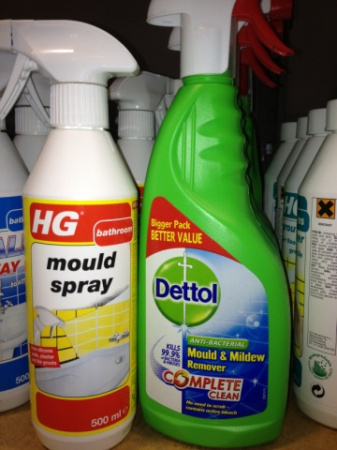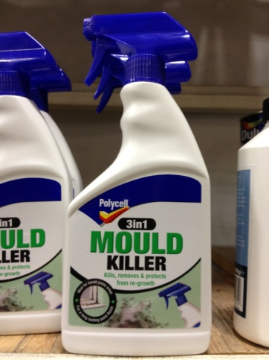

- Keep furniture away from walls, especially unvarnished wood.

- Check and clean, if necessary, behind furniture regularly.

- When people come in with wet coats, they should be hung outside the living area to dry.

- Consider using a dehumidifier – domestic types are now available at a reasonable cost, and can remove a surprising amount of water from the air.

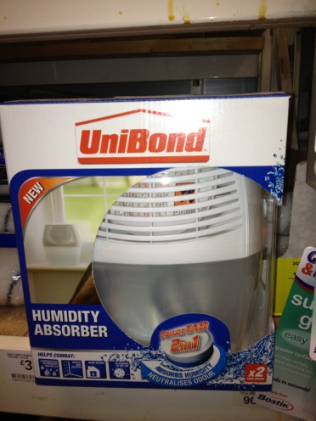

- The use of paraffin heaters and flueless or portable gas heaters is prohibited.

